Event registration process
Once an event is set up and online registration is enabled, it will appear on your event calendar page in DPPA.net, where you can view details and register for the event – from your computer or mobile device.
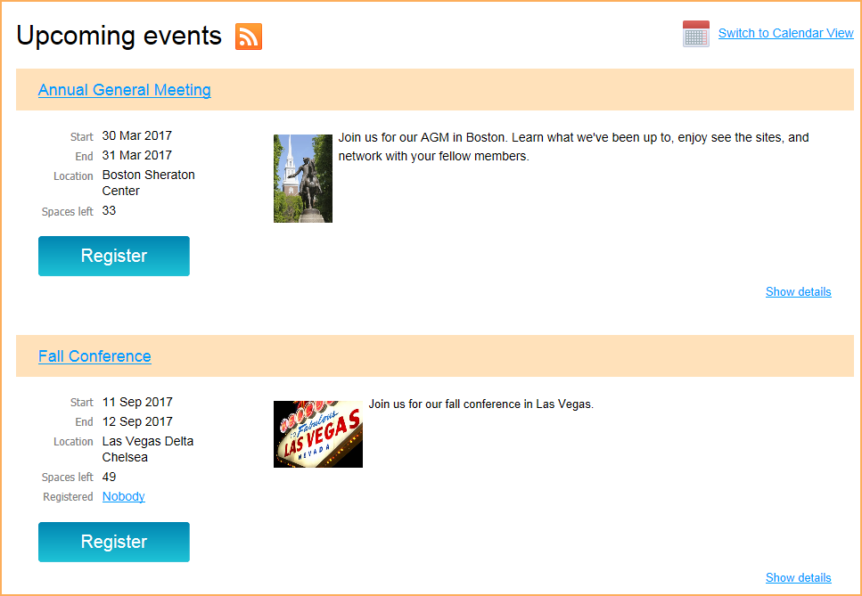
When you go to the DPPA.net site click the Register button for an event, the following steps take place:
- First, you will be asked to enter your email address. If you are already logged in, your email will already be filled in (though you can change it, to register another person). 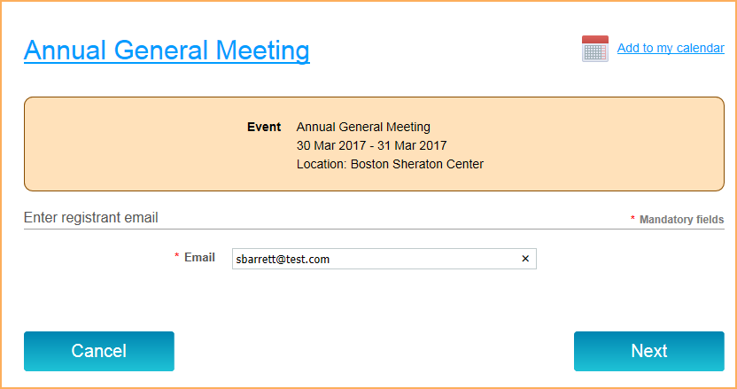

- If there are multiple registration types, you will then be asked to select a registration type. 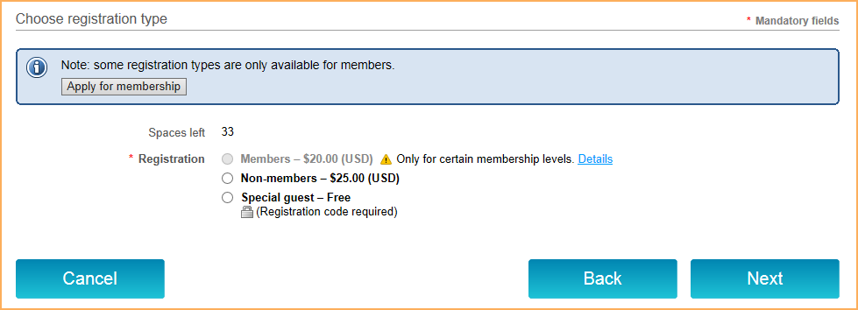
Depending on whether you are logged on or not, some member-only registration types may not be available. If you are not logged in, but your email is stored in our contact database, you will be prompted to log in. If your email is not stored in our contact database, or if you are logged in as a non-member contact, you will be prompted to apply for membership.
If the event registration was set up with restrictions and is not thereby available to you, DPPA will display a message that registration is not available.
- Once you select a registration type and click Next, the main registration form appears. 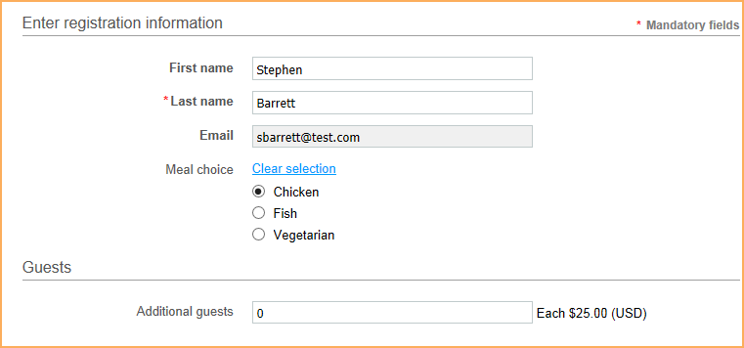
Here, you will fill out the registration form, and select additional event options, if any (e.g. meal preference, event sessions). If the event is set up with a guest registration option, the registrant will be able to add or indicate the number of guests.
- Once you complete the form and click Next, the event record is created.
- What happens next depends on the payment method chosen when the event was set up.
  - If only offline payment was enabled, then the registrant will have the option of canceling or confirming the registration. If the registrant clicks the Confirm button, an invoice will be emailed to them, and a registration summary will be displayed. From the registration summary, the registrant can choose to view or pay the outstanding invoice.
  - If only online payment is enabled, then a Pay online button will appear. Clicking the Pay online button will take the registrant to the online payment screen for your site's payment provider. Any outstanding invoices will be included in the amount being billed.
  - If both online and offline payment is enabled, then two buttons will be displayed: Pay online and Invoice me. Clicking the Pay online button will take the registrant to the online payment screen for DPPA’s payment provider. Any outstanding invoices will be included in the amount being billed. Clicking the Invoice me button will result in the registrant being emailed an invoice – which they can pay online or offline – and a registration summary being displayed. From the registration summary, the registrant can choose to view or pay (online) the outstanding invoice.
After registering for events, registrants can view their event registrations from the My registrations tab on their member profile.
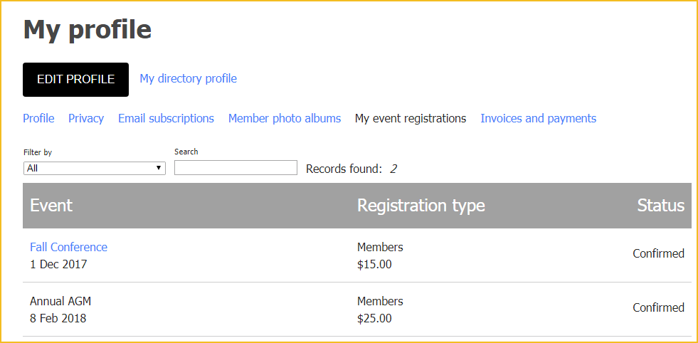
Depending on how DPPA has set up the registration types, registrants may be allowed to cancel their event registrants by clicking on the registration within the list then clicking the Cancel registration button from the registration details.

